GROUP 1
COVID-19
Sentiment Analysis
Vaccination Analysis
and Analyzer Application

Robert Kaszubski | Ashish  Gare | Hera  Gaddi | Rosario  Fabian
DePaul University | DePaul University | DePaul University | DePaul University
rkaszubs@depaul.edu | agare@depaul.edu | hgaddi@depaul.edu | rfabian1@depaul.edu

Abstract
Social media was widely used during the pandemic to help keep people stay connected, follow the latest news and be up to date on the current guidelines, policies, and regulations being set by politicians and health organizations. Twitter is one of the most popular social media platforms and was significantly used to influence the public in various situations occurring during the global pandemic. We scraped millions of tweets based on keywords relating to the pandemic and COVID-19 using the Twint Python library. This data was utilized to perform Sentiment Analysis and LDA Analysis to understand how public opinion above COVID-19 evolved during the pandemic. Likewise, Time Series Analysis and Sentiment Analysis were conducted focusing specifically on a subset of tweets relating on vaccination. There was a strong correlation between the latest information being released and changes in the public’s attitudes. Following our analysis work, a generalized application was created to automatically scrape tweets based on the topic and preferences of the user, and display several pages of analysis (including exploratory, sentiment, and tweet specific) based on the techniques used for the original COVID-19 data.
Keywords: social media; sentiment analysis; public health policies; covid-19; sars-cov-2; covid-19 pandemic; twitter data; twitter scraping; scraping application; application; analysis; modeling; time series; vaccination; kivy; twint; python; tweets; emotions; public opinion; epidemic; self-isolation; quarantine, isolation; self-quarantine, work from home; lockdown; mask; omicron; delta; variant.
Intro
Over the last two years, the world as we know has changed tremendously with the impact of COVID-19 affecting our lives. In this project, we use tweets retrieved from the popular social media website Twitter as our main source of data to initially explore the public’s perception about the Covid-19 pandemic over the last two years and then to build an application which can convey the sentiment of the tweets made a user and how these tweets can be influenced by various figures. We aim to see the various stages of sentiments expressed by the public over the span of 2019 December to 2021 December. At the start of COVID-19 there was a lot of fear and uncertainty about how harmful the virus is and the effects of it on humans. We saw the lockdown being initialized during March end and April start where citizens were only to be home and not leave their houses for any reason. With this effect, a lot of people started experiencing different symptoms of mental disorders and taking that to social media. We were able to scrape these tweets to be able to understand the type of emotions exhibited during the 2 years and how the world has reacted to the situation.
We started off by scraping raw data from social media, here Twitter and decided to see how the tweets made were showing what the user were feeling during the pandemic. We used machine learning and natural language processing to be able to understand the sentiments of helping users understand how the topic is being reacted to on twitter. Our application created helps a user to understand and scrape the type of tweets made regarding a topic and indicate the type of reactions and different words that are more commonly used. This helps them see topics of what they like and be able to see the most trending words, languages, manipulate date and time. The scraper function of the application can be thoroughly customized as the user would require; set any parameters they want to fine search the tweets.
Sentiment analysis is a technical study of people's feelings and opinions [1]. This type of analysis is very insightful to people who want to understand the state of someone's mind and their interaction with society over social media. We created an application that takes the sentiment analysis models and then uses that to be able to see what different topics the user can scrape using the scraping application and then use it to analyze the tweets. We have included 3 distinct types of analysis on the application and 3 different tabs. These tabs perform Tweet Analysis, Sentiment Analysis and Exploratory Analysis for all the tweets that are scraped.
Background
The pandemic led to a lot of changes in people’s lives over the span of two years. Social media played a major part in helping spread news, both good and bad, about the situation. Prior to and during work on the project, we looked at several existing studies about the covid-19 pandemic, and about utilizing Twitter data for analysis. There was a study done to see the change in mental state in the United States by scraping data from Twitter to see how the public was responding to the pandemic [5]. In this we can see how different models were applied to see the impact of the lockdown for many months and show the reaction of users. Similarly, they had scraped the data to be able to make it possible to understand the different sentiments of the users. Since social media contains a lot of raw data, it is useful to extract distinct types of valuable information with it [2]. As there were already a lot of open-source packages for scraping the from Twitter and making it available to scrape over 100K tweets from a period (if existing), it then became more of configuration problem for the devices.
Many of the applications of this analysis just concentrated on the data being presented and we decided we would take it step above and help people use an app which can be understood by non-data science background users. Furthermore, other research encountered was about analyzing the tweets from POTUS and the type of reactions associated with them [6]. In this there were significant indications of the negative sentiments during market opening and models which were able to see when there were positive and negative reactions to the market when he was negative and positive. This research helped us understand the time of the sentiments mattered and made us utilize the average of the times in the graphs in our Sentiment analysis page. We were able to see the different reactions exhibited by the users and by performing this. Similarly, there in 2012 it was conducted in South Korea’s presidency candidates and saw how users and their follower's activity was noted.[6] The attention to certain posts was high compared depending on the day of the week and the candidate in the lead. However, the hour timeline denoted the attention paid to the tweets by these political figures to understand the cycle of the users.
Online social media (OSN) plays a vital role in the events that are occurring. It played a key role in the elections every time and is growing its influence daily with the uprising of influencers and other celebrities taking part in many of the tweets [3]. We saw the benefit of this when we were able to infer to the large word clouds and saw that most of the words used very heavily repeated by influencers and others to be able to gain engagement on their posts. This helped to see the different affiliations they had and overall, the type of tweets they wanted to post were mostly controversial in many ways.
Another topic of research that was looked at was cyberbullying and finding out patterns used models which used Naïve Bayes and Twitter dataset [4]. It was evident that cyberbullying detection improved when sentiment analysis was used but, in this experiment, emotions were not correctly predicted and sought to fight cyberbullying and mitigate it, like that we can detect fake news and mitigate it. In short, all these topics helped inform us of the decisions we would take when proceeding with our project.

Dataset
There are several existing Covid-19 related datasets available from various sources. However, none of these included exactly what we required for this analysis. Often, datasets were only available for specific months or missing several variables. To complete, a sentiment analysis of the entire duration of the Covid-19 pandemic required data spanning the entirety of 2020 and 2021.
We decided to create our own dataset and the final dataset utilized was scraped from Twitter itself. There are several ways of retrieving data from Twitter such as using their API; however, this is a difficult and restrictive process. Twitter must first approve of the project the data is collected for, the tweets that are accessible are limited to a recent timeframe, and only 500,000 tweets are available to retrieve each month. This was unacceptable for the analysis we wanted to complete as we required a few million tweets. We turned to a Python library called Twint.
Twint is an advanced Twitter scrapping tool that circumvents the Twitter API by using web scraping. It allows for a lot of control of what tweets are being retrieved such as setting keywords, the date range of the tweets, the number of likes/replies/retweets a tweet must have to be included, as well as limits on the number of tweets to retrieve. The Twint library is capable of automatically storing the tweets in comma separated spreadsheets or in JSON format. Using the Twint scraping tool retrieves a total of 36 different variables for tweet. These are: id, conversation_id, created_at, date, time, timezone, user_id, username, name, place, tweet, language, mentions, urls, photos, replies_count, retweets_count, likes_count, hashtags, cashtags, link, retweet, quote_url, video, thumbnail, near, geo, source, user_rt_id, user_rt, retweet_id, reply_to, retweet_date, translate, trans_src, trans_dest.
The final dataset was scraped using a total of 30 keywords: covid, covid-19, covid19, coronavirus, sars-cov-2, variant, virus, omicron, delta, pandemic, asymptomatic, ventilator, mask, ppe, distancing, isolation, self-isolation, quarantine, self-quarantine, spreader, outbreak, epidemic, endemic, vaccine, vaccination, vax, anti-vax, jab, immunity, immunizations. These keywords encompassed the key topics of discussion revolving around the Covid-19 pandemic. We chose not to include any public figures such as world leaders e.g., President Donald Trump, or doctors/scientists e.g., Anthony Fauci. This would have led to the inclusion of tweets about the individual or unrelated events rather than Covid-19 in the dataset. Twint was configured to exclude any retweets, as these would be duplicates of existing tweets, and to include only tweets with a minimum of 100 likes. The like count indicates the public engagement with the tweet and excludes spam tweets posted by bot accounts. It also decreases the total number of tweets retrieved to a more workable amount. We likewise did not require all 36 variables to be included and limited the number down to 9 variables: id, created_at, username, likes_count, replies_count, retweets_count, language, tweet, hashtags. The tweet variable contains the actual text of the tweet itself.
Due to limitations with Twint, the scraper was only able to retrieve about 450,000 tweets during a single run. This posed another issue as we needed to scrape several million tweets. The tweets were instead scraped using multiple instances of the scraper, month per month. For March and April 2020, the start of the pandemic, there were so many tweets that those months had to be scraped by two instances. The other months had fewer tweets to scrape. The tweets from each month were then concatenated together in order by year, and then into a complete spreadsheet containing both 2020 and 2021.
The final complete dataset contained 4,502,811 observations (tweets) and took 1.3 Gigabytes of space. But datasets for each year and month were likewise available. Various pre-processing steps were performed on the dataset prior to conducting our analysis. Non-English tweets were excluded, and duplicate tweets were dropped. The tweets were converted to lowercase and all special characters, stop words, HTML and numbers were removed. For performance enhancement, stemming, tokenization and lemmatization was applied on the tweets.
Sentiment & LDA Analysis – Hera
Methodology
NRC Emotion Lexicon Sentiment Analysis
The first part of the analysis focused on answering the research question, how the public's sentiment evolved over time with the implementation of new health policies along with emerging news. To answer this question, we used Sentiment Analysis which is the use of natural language processing to extract and analyze affective state and then aggregate the sentiment scores of all the words in the document. The approach we took was to use NRC Emotion Lexicon, as this enabled us to analyze eight basic emotions: Anger, Fear, Anticipation, Trust, Surprise, Sadness Joy, and Disgust, along with Negative and Positive sentiments. We applied this approach to all COVID tweets and analyzed the difference between these emotions from 2020. vs 2021.
Latent Dirichlet Allocation (LDA) Topic Models
The second Analysis concentrated on answering the research question, what topics are trending throughout the pandemic. To answer this question, we used Latent Dirichlet Allocation (LDA) which is a topic modeling technique used to extract latent topics from a given documentation. It sets out to detect top k topics in a dataset, as described by the most n relevant keywords. In simple terms, it shows terms with high probabilities of association for a given topic. The library “pyLDAvis” was used for an interactive topic model visualization. This showed two things, an intertopic distance map and the top 30 most relevant terms. The intertopic distance map visualizes the topic within a two-dimensional space. The size of the circle, referred to as topics, is dependent on frequency of words that is associated with the given topic. The relevant term for topic shows two bars, a blue bar which represents the overall term frequency, and a red bar that depicts the probability that word is in the topic.
Analysis
The corpus sentiment showed a distinct increase in sentiment around March 2020, shown in Figure 1. This aligns well with the three major events that occurred. On March 11th, 2020, World Health Organization (WHO) declared COVID-19 a global pandemic; March 13th, 2020, President Donald Trump declared a National Emergency; and around March 17th, several states announced shelter in place. Surprisingly, but not to a significant extent, there was a larger percentage of Positive sentiment compared to Negative. This could be due to the proactive measures the respective government and states were taken to keep people safe. As less news started to circulate, the Positive and Negative sentiment started to slowly decline with the Positive sentiment still taking the lead. However, from June 2020 through October 2020, the two sentiments overlapped. This potentially could be related to other events and the division of public opinions. One half of America protested for “opening up America again” which had an economic impact and spiked unemployment rate. The other half of America wanted to prevent overwhelming hospitals and lower the death rates. Towards the end of 2020, the Positive sentiments increased as things were returning to normalcy – infection and death rate declined, and the Food and Drug Administration (FDA) approved emergency use of Pfizer and Moderna vaccines.

In 2021, Positive sentiment were consistently higher throughout the year regardless of current information about a second and third wave of the virus, shown in Figure 1. This was due to larger percent of people being vaccinated or scheduled to be vaccinated, resulting in less serious illness, and therefore reducing any negative sentiment. Another assumption is that people were more familiar with COVID, and research was widely available compared to when COVID was first discovered.
Likewise, the eight emotions mirrored a similar pattern to the two sentiments. Early in 2020, with the announcement of a global pandemic and national emergency, Fear was at top with Trust following close, shown in Figure 2. This seemed logical as COVID was an unknown territory and tons of questions were left unanswered. Further, the death toll was raising and there was no vaccine to prevent sickness. However, the public had trust in the leaders and the new guidelines being implemented. In mid to late 2020, the two sentiments inverted with Trust taking a slight lead. This stayed consistent throughout the year regardless of news. In 2021, there was a larger percentage of Trust. Even though there were ups-downs based on developing news, Trust remained at the top, shown in Figure 3.
Figure 1:
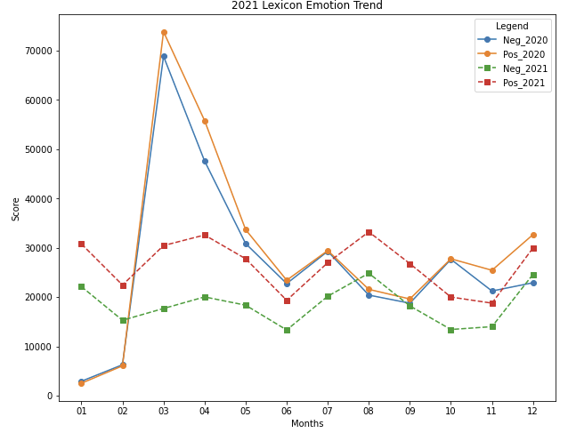

Figure 2:
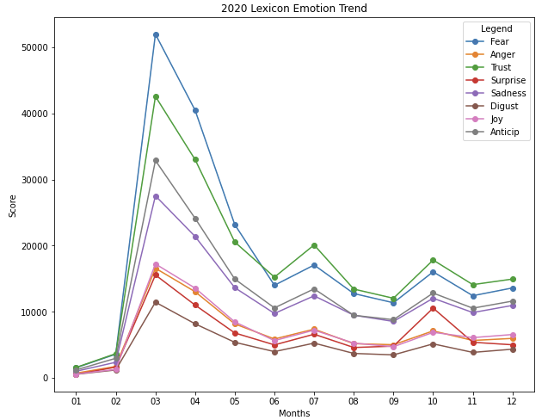
Figure 3:
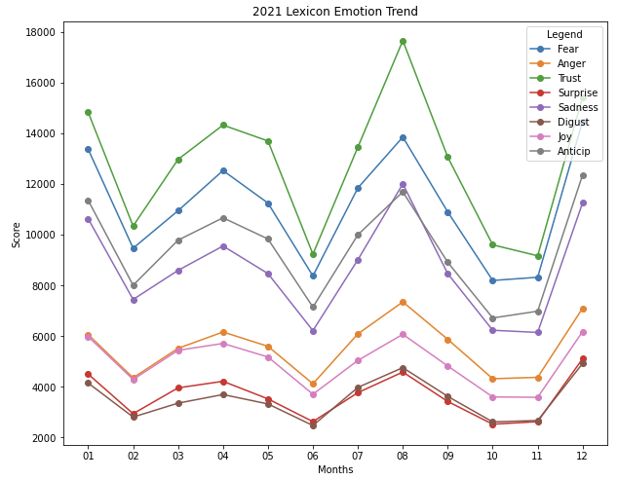
The LDA topic model was performed on the corpus regardless of Positive or Negative sentiment and it used Topic K = 8 and number of word N = 10. The intertopic Distance map showed some overlapping between Topic 1, 2 and 3, as well as some overlapping with Topic 2 and 5. Topic 6 is close to Topic 5, whereas Topics 4, 7 and 8 are spread apart. To get a better understanding of this, we explored the words within the topics, their weights and inferred the topic from the keywords. Top 1 can be summarized by positive cases and deaths. Topic 2 by President, Topic 3 by vaccination, Topic 4 by mandates, Topic 5 by government, Topic 6: health, Topic 7 by policies and people and Topic 8 by mask. This is an indication that the latest information does impact the theme of the topic, but the order of the topic had no significant meaning.

Figure 4:
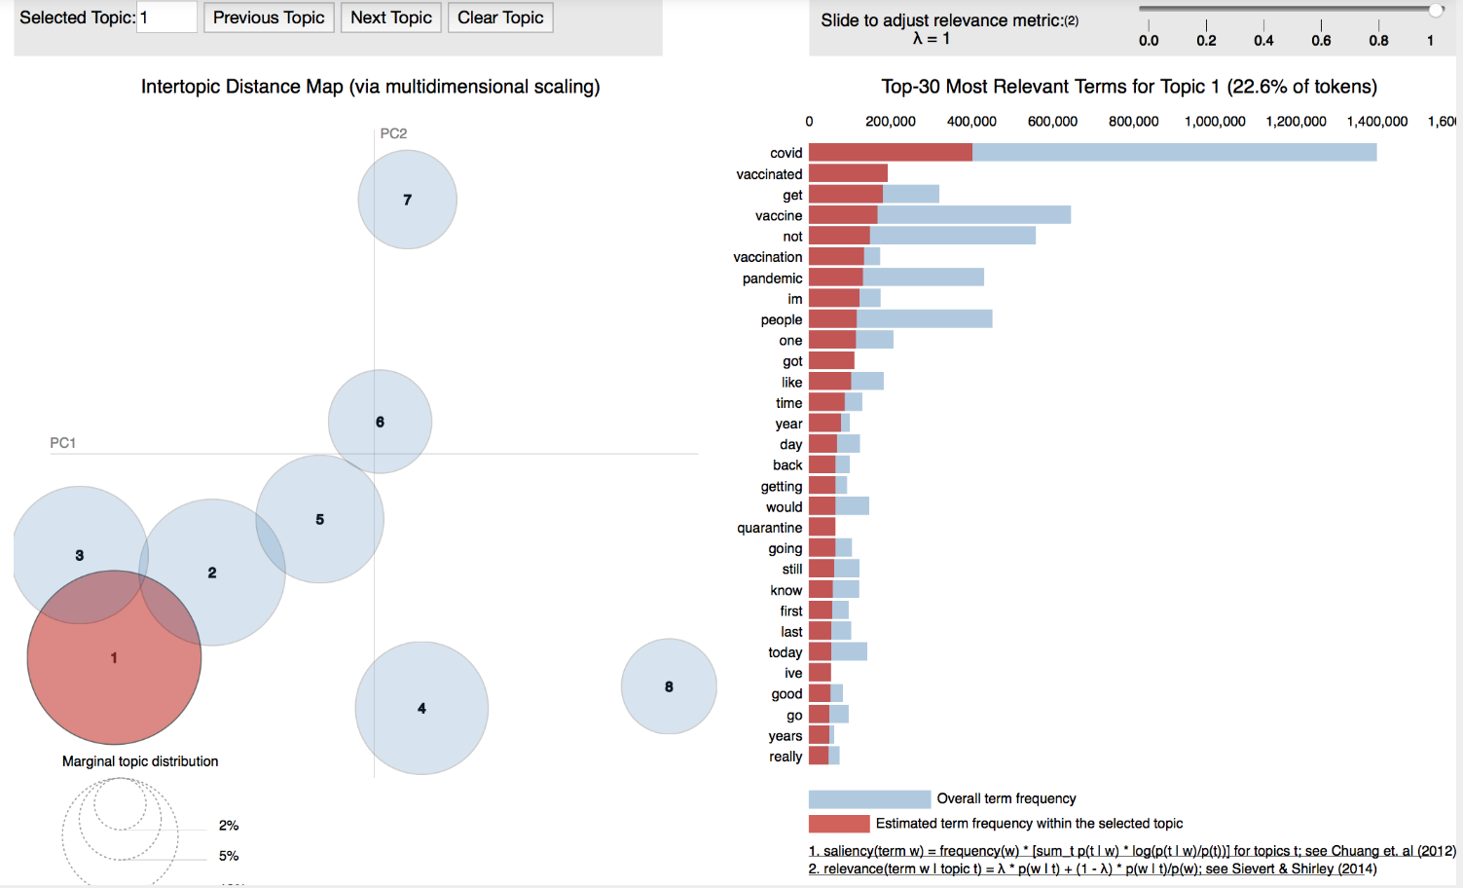

Figure 5:
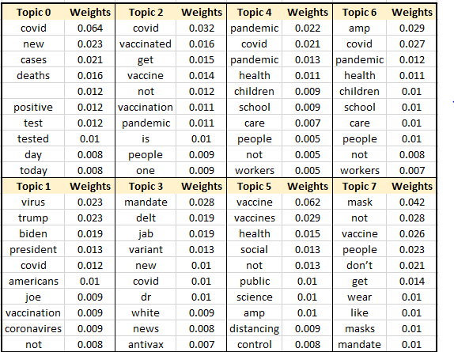
Conclusion
There was a huge shift to social media, specifically Twitter, during the onset of the pandemic. Twitter became the main source for people to stay connected, share experiences and understand what is happening in real time. The heavy use of Twitter gave researchers an opportunity to analyze tweets in diverse ways. We focused on how the public's perception evolved and what topics were trending. Our analysis showed that there was a strong correlation between the latest information being released and changes in the public’s attitudes. The trending topics were also dependent on the news. Further, it was noticeable that towards the end of 2021, online present had significantly declined.
Our analysis had some limitations on the location and demographic which could have easily influenced our results. For instance, the older generation may not be on social media and younger generations may not follow the news as closely as we would hope, and the political views of the states could play a factor. For future, it would be interesting to see public perception changed based on location and be able to see trending topics at different time periods and the magnitude of those topics, rather than just finding the overall topics.

Vaccination Specific Analysis – Rosario
Vaccination Analysis
The study represents analysis about the sentiment of people about vaccination during 2021 and prediction and evaluation of perception of Vaccination in January 2022.
Methodology
Dataset
To understand tweet datasets and everything about Covid, we worked with different sample datasets before we agreed on the final dataset.
The final dataset is a collection of Streaming Covid related tweets from December 2019 to December 2020, there are 3.4 million tweets with 9 variables, they are date, tweet, language, hashtag, Username, Id, number of likes, number of replies and retweet count.
Each variable was studied in detail to evaluate if they should be considered in the analysis, a few variables did not have complete information, it is reason they are not considered in this analysis.
After detailed preprocessing and selection. The 3 important relevant variables we worked with to prepare the dataset were Tweet, Language and Date.

The English language Tweets is about 75% of the overall data and it is the reason we decide to work with English tweets only. After We did NLP preprocessing, duplicate tweets were eliminated, numbers, symbols and emoticons were removed, stopwords filtered, tweets were converted to a lower letter. Finally, Tokenization Lemmatization and Stemming were realized during the creating series step.

Sentiment Target
It is a target model that uses a lexicon to measure and express the intensity of sentiment. It is usually used in Text dataset to convert Text information in categorical values.

Time series
Time Series is a sequence of observations through time, it can be any frequency like hour, week, day, or year. It is used to analyze the information with all of components of Time Series such as volatility, trend, and stationarity. The goal is to understand as the values depend on the previous values.
Forecasting Time Series
It is used to create the model and predict future values; it depends on every series to consider the previous values and get the prediction of the model. How far we can predict depends on every specific series data.

Results and Discussion
Search Distribution Analysis:
The dataset had all Covid related tweets, and this study is about the specific topic of Vaccination. The first step is to filter the tweets of Vaccination topic in Dataset that has all covid related tweets. I used the root of words vaccination and covid and tried different combination of words to filter all tweets related only to vaccination topic. Finally, I found that the distribution of the data in this group looked similar in different scenarios which means that the results will be similar with these words filter.

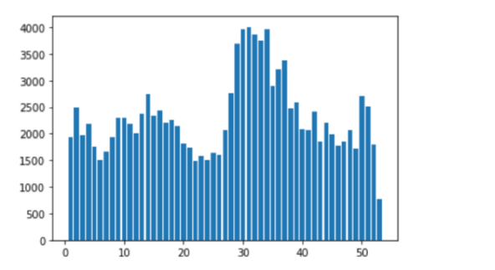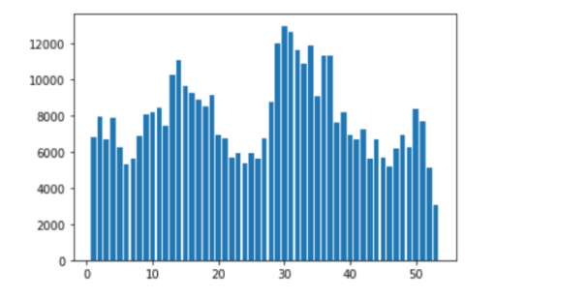

Sentiment Score
We assigned sentiment target by assigning positive or negative sentiment in every tweet. The lexicon comes from Nielsen who studied and developed sentiment values of words. The library is AFINN lexicon, it is a list of English terms rated between –5 (negative) and +5 (positive). Every tweet was applied binary classification, it is 1 when the tweet is positive and 0 when the tweet is negative.

Creating the Sentiment Time Series
The analysis was weekly, and the year is 2021 with 52 weeks (about 12 months) during 2021. The information was grouped to create the sentiment score weekly. It is positive tweets as numerator and denominator is positive and negative tweets. The range goes from 0 to 1, where 0 means strongly negative sentiment and 1 strongly positive sentiment.
It consists of 1.3 million vaccination tweets which were transformed in 52 values that represent the sentiment score of vaccination for every week during 2021.

The visualization shows that after June 2021 a perception of vaccination turned negative based on people posting on Twitter. It is based on the sentiment score of below 0.5 which expresses negative score.

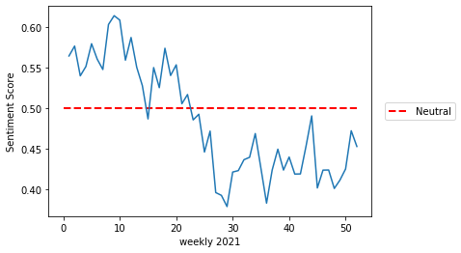
Time Series Forecasting
The vaccination Series 2021 were used to calculate prediction for the next for 4 weeks of 2022. The methodology is Time Series. The exploration analysis shows that the series is not multiplicative and according to Jarque Bera Test Normality, it is p-value = 0.1326. It means the series is normal and the series is not stationary. After modeling processing and residual analysis, the final model is ARIMA (1,1,5) and the Ljung –Box Test did not fail, RMSE is 0.03 and the residues are white noise. It captures the volatility of the series; we can see a positive trend during January 2022

The forecasting shows the values have mean between 0.45 and 0.49 with a 95% interval of confidence, it indicates that the values could take 0.5 and that the perception is neutral, 50% of comments are positive and another 50% negative and trend gradually becomes positive with increase of positive tweets about vaccination.

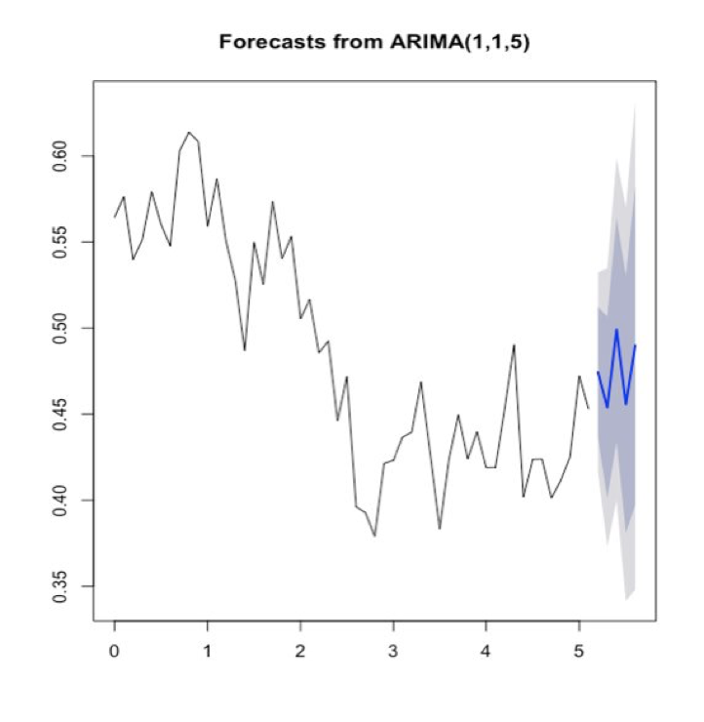

Point Forecast Lo 80 Hi 80 Lo 95 Hi 95
Week 1 0.4743 0.4364 0.5122 0.4163 0.5323
Week 2 0.4538 0.4009 0.5067 0.3729 0.5347
Week 3 0.4991 0.4342 0.5641 0.3998 0.5985
Week 4 0.4558 0.3810 0.5305 0.3414 0.5701

Conclusion

The visualization shows that after June 2021 a perception of vaccination turned negative based on people posting on Twitter. It is based on the sentiment score of below o.5, which expresses negative score. Sentiment score represents average sentiment score for all tweets posted. The Time Series visualization shows that there are more negative comments about vaccination. The forecasting values show an increase of positive comments for January 2022 and the trend is positive. Also, the volatility of the series is captured for the model.
Twitter is available to collect for everybody, it is reason streaming data is the trend right now to collect current information. In this this study the perception of people about vaccination shows clearly what happened during 2021 and the forecasting of January 2022.
Even though many suggest that tweet data may not represent overall public sentiments, studies indicate that the results are actually similar to public survey data. In this particular study we use all information of covid and vaccination, it makes results more precise.

Application
After completing most of our analysis work, we saw that we had a good foundation for an application. The key was combining the scraping and analysis process into a seamless user experience. The application is meant to simplify the entire process explained in this report. With a few inputs and clicks, the user can scrape any data they wish from Twitter, then automatically be greeted by three dashboards of interactive analysis: exploratory charts and data, sentimental trends over time, and an in-depth view of each individual tweet.
Development began after selecting a platform to build the application in. As all the existing coding was performed using python, it made sense to look at other python libraries for building applications. Kivy was selected. Kivy is an open-source Python framework for developing applications. It can run on a variety of platforms including desktop platforms: Windows, macOS, Linux, and mobile platforms: Android, iOS. We built a strict desktop application that requires a minimum screen resolution of 1280x720. Kivy includes a variety of built-in widgets and support for building custom and extended widgets that allow for easy user interface creation. While Kivy is built in Python, it also features its own language KV. KV is used for the design portion of the application and allows for the placement and design of widgets on the screen. It easily interacts with the main Python file and data can be passed between the two languages. The Python portion of the application includes most of the functionality. Each page/screen of the application is created as its own class, with its own instance and class variables, and methods. Some of the methods here are rewritten sections of the original analysis code, turned into parameterized functions accepting user input but most are newly created for the application.
The application consists of 6 main screens. The first is the home screen. The home screen is kept basic. It features the name and logo of the application. Underneath is an information icon that opens a popup with general information about the application when clicked. An information icon is present on every other screen in the application under the title of that page. The information popups for all other screens present information relevant to only that page that users can refer to in moments of confusion. The bottom of the home screen features two buttons that navigate the user to either scrape new data or use an existing dataset previously scraped or included with the application.
Figure 6. Application Scraper Screen
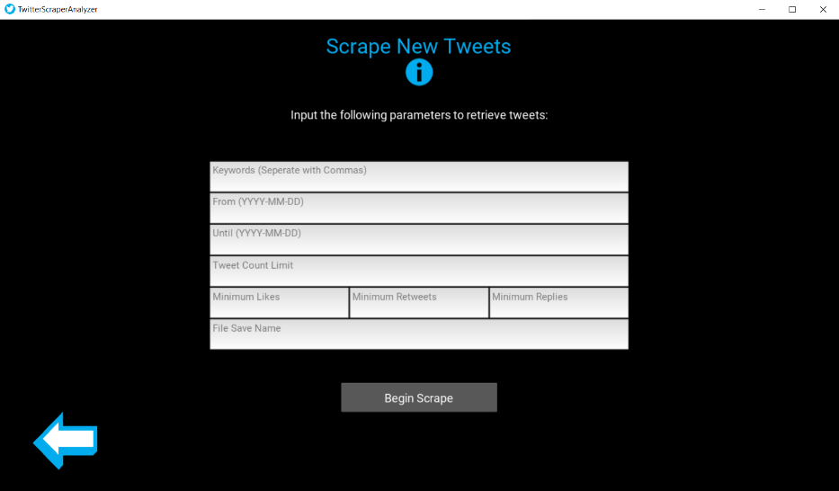
The scraper screen (Figure 6) is used to retrieve new data from Twitter based on user input using the Twint advanced scraper library. It prompts the user to fill in several text fields. The first thing the user must provide are the keywords to query Twitter with. They may include a single keyword or multiple keywords separated by commas. The user has the option to provide a period for the tweets in the format YYYY-MM-DD. If the user leaves these fields empty, the application will scrape the most recently available tweets instead. The user can limit the number of tweets retrieved, by default this is set to 100. We encourage you to use anywhere from 100 to 1000, as this will only take a few seconds to process. Attempting to scrape larger datasets is possible but may take longer. Scraping 100,000 tweets is estimated to take as long as an hour in this case. The user can also specify the minimum number of likes, retweets, and replies. These are encouraged but not required. They are an effective way of filtering data from Twitter and ensure you capture a wide date range. Twint works by beginning at the end date and working its way back to the start date. If it hits the limit before then, it will stop. Filtering by likes, retweets, and replies ensures that fewer tweets from each day are captured. If neither are specified and default to 0, then it is likely that all tweets retrieved will be from the same day or even the same hour. There are a lot of tweets posted each day. Finally, we required a file save name. This is to store the tweets in a local comma separated spreadsheet for analysis and future usage.
After scraping a dataset, you are automatically navigated to the Existing Data screen. You can also navigate here from the home screen if you do not wish to scrape new data first. Your scraped data will appear on this screen. We have also included 6 sample datasets if you wish to jump right into the analysis process without scraping your own data. These sample datasets include sets of 100, 1000, and 10,000 tweets. To proceed to the analysis portion of the application, simply click on any dataset to highlight it, then press the load file button. The selected data is processed at this point, prior to entering the first analysis screen. Special characters, stop works, html links, and numbers are all removed from the tweet text. The original text is still stored however for display on certain analysis pages. The data is tokenized, stemmed, and lemmatized before emotions are extracted and stored for each tweet using the NRC emotion lexicon library.
Figure 7. Application Exploratory Analysis Screen
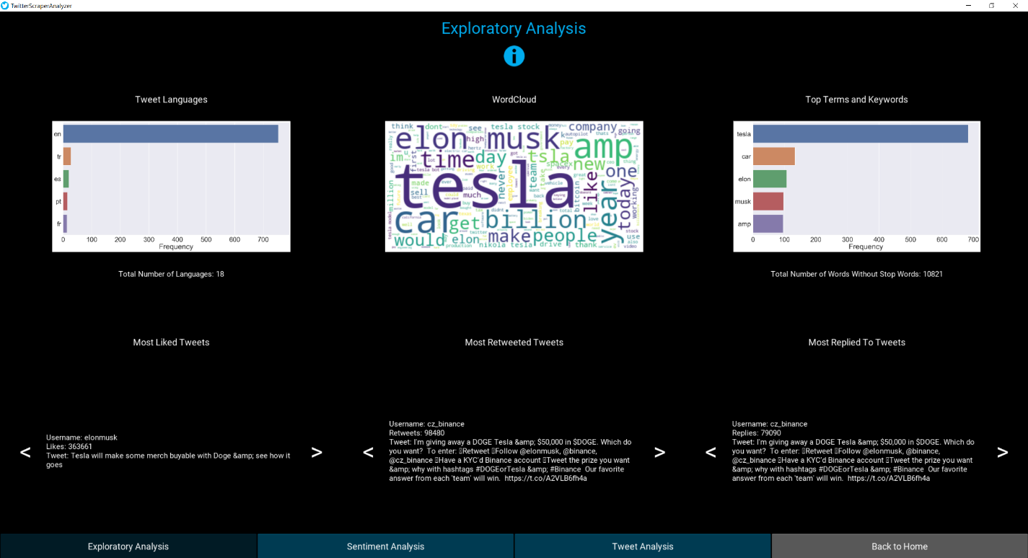
The analysis portion of the application is split into three different screens. The first screen you are automatically redirected to is the exploratory analysis screen. The exploratory analysis screen (Figure 7) offers a high-level view of the dataset. There is a language plot highlighting the top 5 most prevalent tweet languages in the selected data. Beneath this is a count of the total number of languages. There is a similar plot displaying the top 5 most frequent terms or keywords in the data along with a word cloud. The word cloud likewise shows word frequency but includes terms beyond the top 5. Below the three plots, there is an interactive display of the most popular tweets. These are filtered by the most liked, most retweeted, and the most replied to. Each category has arrows for navigation and highlights the top 10 tweets in each. The bottom of all three analysis screens contains a navigation bar. The navigation bar redirects to the other analysis screens as well as back to the home screen to scrape new data or open a different dataset for analysis.
Figure 8. Application Sentiment Analysis Screen
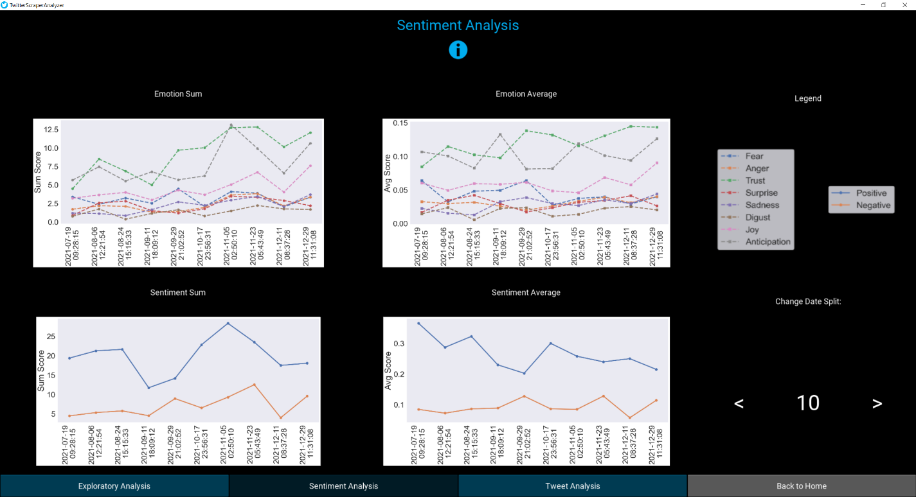
The sentiment analysis screen (Figure 8) features four time series plots displaying emotion and sentiment change over time. The data is evenly split into data ranges to prevent clutter from plotting every single tweet individually. The user can control how many times the data is split using arrows displayed on the bottom right of the screen. For example, if the user is analyzing a week’s worth of data, and selects 7 splits, there will be one point on the plot per day. For each date range split, the tweet emotions are aggregated by sum and by average. These results are then displayed on the plots. Two of the plots display emotion data by sum and by average. This includes the following emotions: fear, anger, trust, surprise, sadness, disgust, joy, and anticipation. The other two plots highlight positive vs negative sentiments by sum and by average.
Figure 9. Application Individual Tweet Analysis Screen
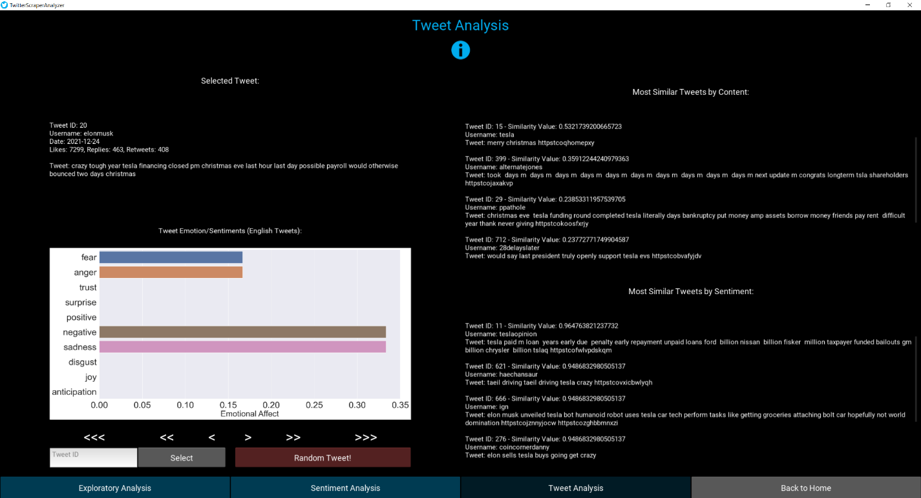
The individual tweet analysis screen (Figure 9) offers an in-depth perspective on each individual tweet. Upon entering this screen, the first tweet in the dataset will be displayed. Below the tweet is a chart displaying the emotions and sentiments of that single tweet. On the right half of the screen is a scrollable view of the 5 most similar tweets by content, and 5 most similar tweets by sentiment. The content based similar tweets are found by comparing the cosine similarity of the TFIDF weights of each tweet. These are precalculated when clicking on this screen, so they do not have to be recalculated each time a user selects a different tweet. The similarity matrix is stored as a variable. The one drawback from this approach is that this page is very memory reliant, if you are using a dataset with several tens of thousands of tweets, it will not work if you do not have enough memory on your computer. The trade-off, however, is that it works very quickly for smaller datasets. This has been tested on as many as 10,000 tweets. The sentiment based similar tweets are found in a comparable manner by calculating the cosine similarity of the emotions and sentiments of the selected tweet, to every other tweet in the dataset. Likewise, the similarity matrix is stored for quick navigation. The navigation is found on the bottom left of the screen. There are arrows that allow the user to increase and decrease the id of the current tweet by 1, 10, or 100 at a time. The user can likewise search for a specific tweet by the tweet id, which corresponds to its row index in the dataset. There is also a random tweet button that automatically selects a random tweet to analyze.
Once a user is done looking at the analysis screens, they can hit “back to home” to return them to the first screen of the application. At this point, they can scrape new data or open a different dataset. The installation of the app is made easy. It runs on all OS platforms and the only limitation would be the configurations of the user system. The entire code is available on GitHub along with the ReadMe.md files explaining the instructions for installations. We made sure this method works particularly well as an exe would only suffice to windows and not be available on the other major OS platforms. This is the full application. We believe it is a valuable tool that automates a complicated process and provides critical insights on public opinion and perceptions about any given topic.
References
- Ravi K, Ravi V. A survey on opinion mining and sentiment analysis: tasks, approaches and applications. Knowledge-based systems. 2015 Nov 1; 89:14–46. https://linkinghub.elsevier.com/retrieve/pii/S1876201820302008
- Additional information Notes on contributors Andreas Jungherr is a research associate at the Chair for Political Psychology at the University of Mannheim. (n.d.). Twitter use in election campaigns: A systematic literature review. Taylor & Francis. Retrieved March 17, 2022, from https://www.tandfonline.com/doi/full/10.1080/19331681.2015.1132401?casa_token=1BrRm2q6hGkAAAAA%3ApR-8_itbGUWPNivMqCXqRh_uaYzZ4LvzU2USgqbP20XCHPlFXDTBAa0uhcz8_XwsKWhiSRA1PGUuDw
- Reyes-Menendez, Ana, et al. “Understanding #WorldEnvironmentDay User Opinions in Twitter: A Topic-Based Sentiment Analysis Approach.” MDPI, Multidisciplinary Digital Publishing Institute, 13 Nov. 2018, https://www.mdpi.com/1660-4601/15/11/2537.
- Valdez1, Danny, et al. “Social Media Insights into US Mental Health during the COVID-19 Pandemic: Longitudinal Analysis of Twitter Data.” Journal of Medical Internet Research, JMIR Publications Inc., Toronto, Canada, https://www.jmir.org/2020/12/e21418/
- Kinyua, Johnson D., et al. “An Analysis of the Impact of President Trump's Tweets on the DJIA and S&P 500 Using Machine Learning and Sentiment Analysis.” Journal of Behavioral and Experimental Finance, Elsevier, 11 Dec. 2020, https://www.sciencedirect.com/science/article/abs/pii/S2214635020303762.
- Ko, J., et al. “Model for Twitter Dynamics: Public Attention and Time Series of Tweeting.” Physica A: Statistical Mechanics and Its Applications, North-Holland, 28 Feb. 2014, https://www.sciencedirect.com/science/article/abs/pii/S0378437114001435.

Contributions (one sentence each)
Robert- Coded the entire application, scraped, and created the Covid-19 dataset, wrote the corresponding application and dataset sections in the report, and assisted others as required with their portions of the project such as the requirements/exe with Ashish.
Hera- Did the pre-processing, EDA, Sentiment Analysis, LDA and wrote the methodology, analysis, and conclusions.
Ashish- Helped Robert in assisting with the scraping and application. Created the requirements, and installation guides for the application for seamless usage. Did the abstract, background, and introduction.
Rosario- I worked exploration-pre-processing, sentiment Analysis Vaccination (positive / negative), Creating the sentiment Time Series Vaccination, Forecasting, Methodology, analysis, and conclusions.

